***Methods—***

**Study species—** The Eastern oyster, *Crassostrea virginica*, is native to subtidal reefs along eastern shores of North America (Gulf of St Lawrence to the Gulf of Mexico) (cite). Due to a wide salinity and thermal tolerance, however, *C. virginica* has been successfully introduced and is commercially grown on the west coast and in Hawaii (cite). We sourced juvenile oysters (size distribution) from a Hog Island Oyster Company in Tomales Bay, CA (coordinates) approximately 6 months after their arrival from X stock location. On 22 July 2022, oysters were transported in coolers (~60 min) to the UC-Davis Bodega Marine Laboratory (BML; Bodega Bay, CA), where they were acclimated in commercial grow bags to bubbled, flow-through seawater (at + X C) sourced from adjacent ocean waters (salinity ~ 34). Individuals were fed X% of their wet mass in algae every other day, using a mixed algal diet (SFD based on cell densities) recommended by growers (personal comm; cite?). Three days prior to the start of the experiment, we adhered the left valve to a X type plastic plate using X marine epoxy (n = 49 per plate, n = 12 plates).

**Oyster growth experiment—** We held oysters in target TA and salinity conditions (see *Experimental conditions* below, Figure 1) for 5 weeks to quantify the effects of alkalinity and salinity on relative shell growth (surface area and thickness) and tissue mass (n = X total). We defined surface area growth rate as an increase in valve area (mm2) between t0 and tx, divided by the length of the interval (tx – t0; d-1) and shell thickness as the shell mass per area (mg/mm2). We quantified oyster surface area growth over three discrete increments (0-36 ‘net’, 0-18, 18-36 days) from ImageJ software (v.X) analysis of aerial photographs (with a scale bar) taken on three occasions (12.2 MP camera; day 0, 18, 36). Mortality of oysters was recorded at the same time as water changes, and dead shells were promptly discarded. We sacrificed all remaining live oysters on day 36, measuring shell mass separated from tissue mass and dried at 60C for 48-hr. We divided shell mass by surface area to compute shell thickness and tissue mass by shell mass to compute the biological condition index (cite).

Fig. 1

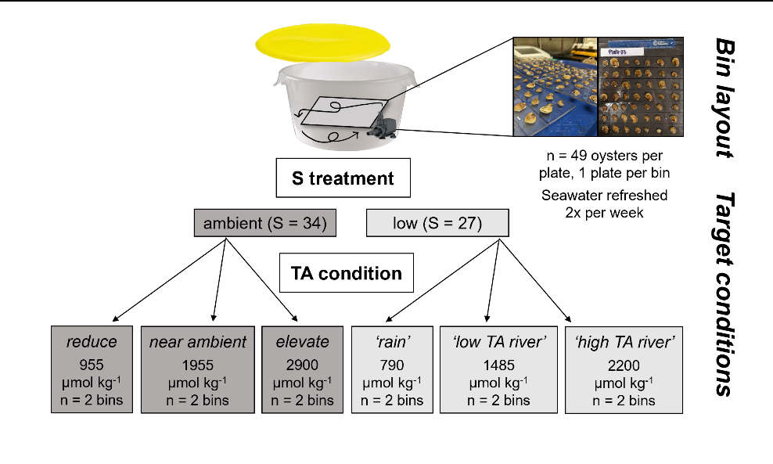

**Experimental conditions—** Oysters were kept in isolated seawater of one of two salinity treatments coupled with one of three alkalinity conditions for 5 weeks (X; Figure X). We fed animals daily and primarily kept them in the dark (except for water change periods) to prevent shadows from disrupting activity (cite). Under ambient salinity treatments, oysters were exposed to reduced, near ambient (serving as a pseudo control) and elevated TA (mean TA = 1000 =-, 1950 +-, 2900 +- umol kg-1). TA conditions in low salinity treatments targeted the result of diluting ambient seawater (TA = 2250 umol kg -1, S = 34) with distilled freshwater (of low or high pCO2) or a river with TA near ambient (mean TA = 800 =-, 1500 +-, 2200 +- umol kg-1).

We performed complete seawater changes every third day to refresh targeted conditions (see *Chemical manipulation of seawater* below), at which time bins and recirculating pumps were thoroughly rinsed. Prior to and again after water changes, we measured experimental seawater temperature, salinity, pH voltage, and dissolved oxygen concentration with a handheld multi-parameter sonde (YSI X). Concurrently, we measured pH with spectrophotometric for half of the sonde measurements (calibrated daily with m-cresol dye standards, Easley and Byrne 2015), and used this relationship to translate all sonde pH voltage readings to total scale pH.

We determined seawater alkalinity by collecting and freezing 250ml seawater samples before and after water changes for later determination. We analyzed carbonate alkalinity concentration on a Metrohm 855 Titrosampler, where we corrected titration acid concentration daily with certified reference materials from the laboratory of Dr. Andrew Dickson (Scripps Institute of Oceanography).

We used measurements of seawater TA and pH, in combination with salinity and temperature to compute the full set of seawater carbonate system parameters employing the *seacarb* package in R (version 3.3.1). In our *seacarb* estimates, we used equilibrium constants determined for our salinity and temperature ranges (K1 and K2: Lueker et al. 2000, Kf: Perez and Fraga 1987, Ks: Dickson 1990). For simplicity, we will largely refer to the seawater carbonate system in terms of alkalinity, though we emphasize that additional parameters are required to fully describe seawater conditions (Table S1; see also Zeebe and Wolf-Gladrow 2001) and that these parameters could influence oyster growth independent of TA and pH (cite).

**Chemical manipulation of seawater—**Every third day, we refreshed the carbonate system of the experimental seawater in each bin with a complete water change, as follows. Two days prior to each water change, we depleted seawater TA to negligible concentrations in large sumps (n = 4/ water change) by adding hydrochloric acid and strongly bubbling with ambient air. This method drove the carbonate system equilibrium reactions towards CO2, and allowed it to offgas out of seawater. We then mixed prepared seawater with distilled freshwater and adjusted the carbonate system back to desired TA (and high pH (> 7.8) using premade solutions of NaHCO3 (sodium bicarbonate) and Na2CO3 (sodium carbonate) with HCl (Waldbusser et al. 2015, Ninokawa et al. in review).

Experimental bins had lids but were not tightly sealed due to a gap created by the pump power cord, which may have had consequences for CO2 exchange and pH between water changes. Seawater temperature, salinity and TA exhibited similar variability over the course of the experiment, however, salinity and TA treatments remained independent (Figure 2). We saw declines of 0.4 pH units between water changes in control bins without oysters but negligible changes in seawater TA, indicating a slow uptake of atmospheric CO2 by experiment seawater. Continuous mixing with pumps ensured oxygen saturation remained high (> 80% cite), though, measurements from two bins did fall below 80% on two separate occasions due to pump motors failing (pumps were promptly replaced upon measurement).

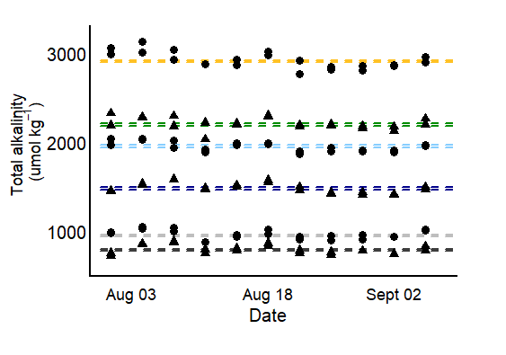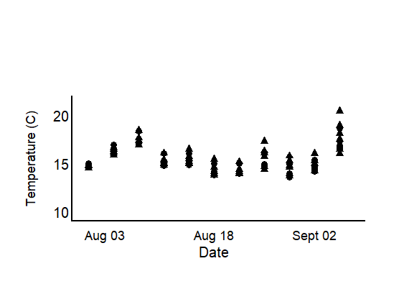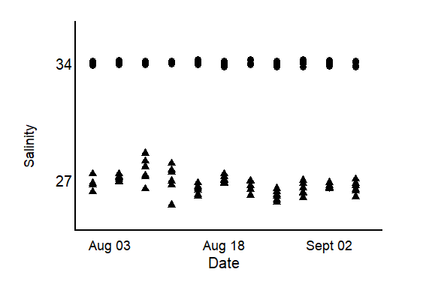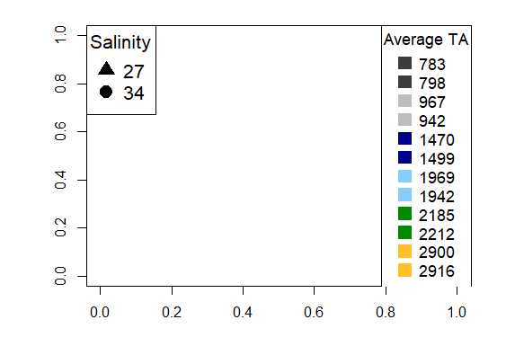

Fig. 2

**Statistical analysis—**

1. **LME with TA as a factor in determining differences in effect sizes of the treatments (shell area) amb S**
   * **Assumptions met?**
     + **To test for variance homogeneity among treatment groups in a mixed-effects model, you can use Levene's test**
     + **Model: (Net_growth.d ~ factor(TA.treat.x), data = amb.S) FAILED**
     + **Transformed: FAILED**
   * **Final model:**
   * **Variance explained?**
2. T-test high S vs low S at amb salinity
   * **Assumptions met?**
     + **To test for variance homogeneity among treatment groups in a mixed-effects model, you can use Levene's test**
   * **Final model:**
   * **Variance explained?**
3. **LME with TA as a factor in determining differences in effect sizes of the treatments (shell area) low S; Tukey HSD posthoc analysis to determine significance among treatments.**
   * **Assumptions met?**
     + **To test for variance homogeneity among treatment groups in a mixed-effects model, you can use Levene's test**
   * **Final model:**
   * **Variance explained?**
4. **LME with TA as a factor in determining differences in effect sizes of the treatments (shell area) amb S; Tukey HSD posthoc analysis to determine significance among treatments (TA and dps).**
   * **Assumptions met?**
     + **To test for variance homogeneity among treatment groups in a mixed-effects model, you can use Levene's test**
   * **Final model:**
   * **Variance explained?**
5. **LME with TA as a factor in determining differences in effect sizes of the treatments (shell area) low S; Tukey HSD posthoc analysis to determine significance among treatments (TA and dps).**
   * **Assumptions met?**
     + **To test for variance homogeneity among treatment groups in a mixed-effects model, you can use Levene's test**
   * **Final model:**
   * **Variance explained?**
6. **LME tissue mass ~ TA + S**
   * **Assumptions met?**
     + **To test for variance homogeneity among treatment groups in a mixed-effects model, you can use Levene's test**
   * **Final model:**
   * **Variance explained?**
7. average + SE vs control + SE shell surface area
8. Seawater table with carbonate system parameters listed for each treatment (ave +- SE)
9. **Average tissue mass control vs in treatments/average CI in control vs treatments**

*To understand whether abrasion from sand of differing coarseness might influence dissolution, we computed the difference between dissolution rates of mussel valves in abrasion treatments, and those of unsanded, control valves. We then used a Welch’s independent sample t-test to determine whether differences in average dissolution existed between the sanding treatments. Assumptions of normality and homogeneity of variances were assessed visually using qq-plots.*

*We used a two-way ANOVA to compare average periostracum cover in adult mussels collected from the field at two relative tidal heights and three levels of sun exposure. We dropped the interaction term between the treatments after confirming it failed to explain significant variability in the model. Using tidal height and sun exposure as categorical predictors to explain periostracum cover, we then ran a TukeyHSD test (95% confidence) to identify which microhabitat types differed from one another via pairwise comparisons.*

***Results—***

***Need to mention the notoriously high variability in the highest TA treatments,***

***Was the effect of SA.start***

**Net shell growth—**Surface area growth was higher in all experimental bins than in non-experiment oysters (fed weekly and kept in flowthrough lab seawater), indicating experimental conditions facilitated elevated shell growth. Patterns in ambient S. Patterns in low S. In our case, low S interacting with TA produced a higher influence than either change alone. Although we did not directly quantify seawater-driven shell loss, visible loss of organic periostracum material and underlying, external shell was apparent by day 18 of the experiment as a function of the CaCO3 calcite mineral form saturation state (Figure X). We did not detect a significant difference in the measured shell thickness, however, indicating that oysters were able to maintain similar shell mass per area (stats).

In ambient salinity, net shell growth did not significantly differ between oysters exposed to reduced, ambient or elevated alkalinity (stats). However, low TA seawater coincided with a saturation state of calcium carbonate < 1 (calcite mineral form), suggesting seawater-driven dissolution signal probably also played a role. In ambient and elevated TA, we estimated seawater to be supersaturated in respect to CaCO3 (calcite) (omega > 1). In this case, oysters in low TA would have needed to compensate for external, seawater-driven shell loss by increasing biological calcification rate, relative to oysters exposed to non-corrosive seawater in order to achieve similar net shell growth overall.

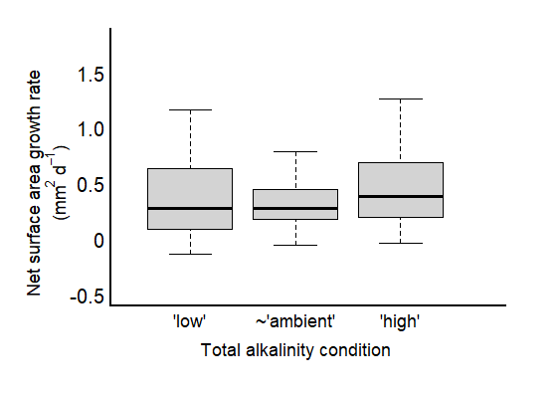

Fig. 3

Net shell growth was higher when low salinity was coupled with the highest of the three TA conditions. In fact, shell growth rates were higher in low S, ambient TA conditions than in each of the ambient salinity TA conditions, albeit with more variability surrounding the average. We saw a similar pattern in low salinity conditions, where oyster net growth was similar in two different TA conditions (X and X) that fell below and above CaCO3 saturation. However, growth in both low S and TA conditions was significantly lower than in the ambient salinity, indicating that although shell loss from abiotic dissolution was compensated, oysters performed worse overall when low TA accompanied lower S, regardless of saturation state.

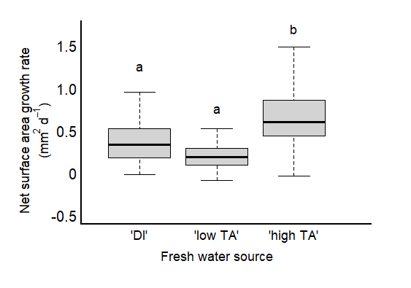

Fig. 4

**Incremental shell growth—**Oyster net growth was predominantly driven by growth occurring in the first experimental increment (0-18 days), as overall growth rates were significantly reduced in the second increment (18-36 days) (Figure x). Regardless, growth patterns changed, in the second incremental period suggesting that the effect of elevated TA, although weak, may strengthen the longer an oyster is exposed to high TA conditions (independent of salinity). The effects of TA on incremental growth detected in the second experimental increment, though, contributes far less to overall growth patterns than the negligible effect of TA in the first increment.

We saw benefits of high TA on growth in low salinity conditions after the first experimental increment, whereas, the effect of TA was not detected in ambient salinity until the second increment. This may suggest that oysters were able to switch over their physio machinery to optimize growth in their preferred condition (lower S and high TA) more quickly than those in ambient salinity.

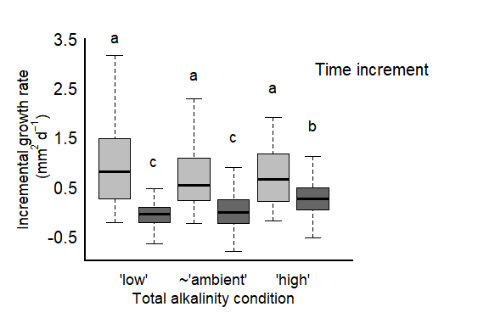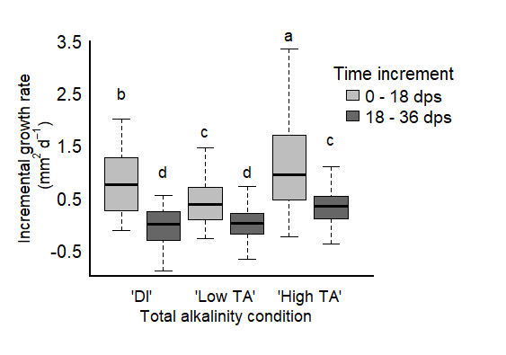

Fig. 5

**Tissue growth and condition index—**Oysters maintained similar tissue mass, that was greater than average non-experiment oysters, in all salinity and TA conditions (stats). Further, oyster tissue mass to shell ratios were higher in all treatments than in non-experiment oysters, treatment conditions supplemented an improved biological condition. Oyster condition trended lower in X condition, though, the means didn’t differ statistically (stats). As tissue mass didn’t vary, this suggests differences in biological condition among oysters, were likely driven by differences in shell growth and not tissue mass.

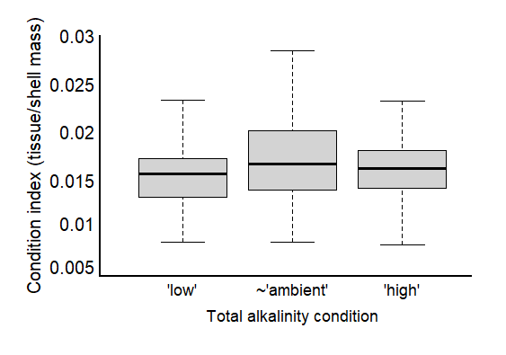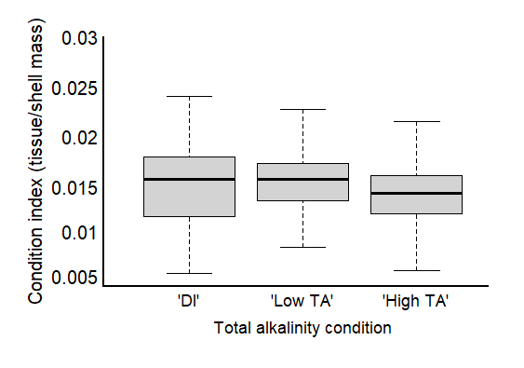

Fig. 6

Table 4. Results of mixed effects, linear model testing the effects of salinity, total alkalinity, and mussel condition index on rates of oxygen consumption (µmol O2 hr-1 ) in adult *Mytilus galloprovincialis* mussels. L-Ratios and p-values were recorded during backward stepwise model selection and refer to the ANOVA test output between the full model and a model with the specified predictor omitted. Bolded values denote a significant effect, determined by alpha < 0.05. The final model: O2 consumption rate ~ log(S) + log(TA) + Condition index, accounted for ~ 13% of the variation).

|  |  |  |  |  |  |  |
| --- | --- | --- | --- | --- | --- | --- |
| **Fixed Effects**  marg. r2 = 0.12  cond. r2 = 0.13 | **Estimate** | **Std. Error** | **t-value** | **df** | **L. Ratio** | **p-value** |
| Intercept | -0.0126 | 0.0110 | -1.1424 | 93 |  | 0.2562 |
| Condition Index | 0.0188 | 0.0070 | 2.6850 | 93 | 5.8396 | **0.0157** |
| Total Alkalinity | 0.0008 | 0.0011 | 0.7021 | 93 | 0.5609 | 0.4540 |
| Salinity | 0.0033 | 0.0014 | 2.2819 | 93 | 5.5896 | **0.0181** |
| **Random Effects** | **Intercept** | **Residual** |  |  | **L. Ratio** | **p-value** |
| Trial date | 0.0002 | 0.0022 |  |  | 0.0795 | 0.7780 |

***Discussion—***

Prior to arrival at BML, conditions in Tomales Bay were marine-dominated due to upwelling (cite), with many oysters still characterized as ‘dormant’ to professional farmers (personal comm.).

Oysters repurpose periostracum material as ‘cement’ to adhere to firm bottom when settling naturally.-->changes in perio under OA or changed food/more maintenance costs.

coastal ‘living wall’ protection from sea level rise along X coast (cite). Shells have been posed as a potential mitigation tool for coastal acidification (cite) and are the preferred substrate for growers (cite), thus extending their importance after death.

Oyster growth was positively influence by [TA], in ambient and low salinity conditions

1. When changes in [TA] occurred in ambient S conditions X happened
   1. Which was largely driven by high incremental growth in the first two weeks, with incremental growth declining between week 2-5 in the ambient and high TA conditions…(Fig 5)
2. Oyster growth is maintained when alkalinity is severely reduced below ambient conditions (60% reduction) in ambient salinity(Fig 2)
   1. Which was largely driven by an increase in incremental growth **after** 2 weeks of exposure to low TA conditions (Fig 5)
3. We also saw X effect of changes to [TA] coinciding with abrupt acclimation to low S conditions.
   1. Oysters exposed to freshwater inputs that have elevated [TA], have higher growth than those exposed to rainfall/low TA rivers (Fig3)
      1. Which was largely driven by increased incremental growth in the first two weeks, with incremental growth declining between week 2-5…(Fig 5)
4. We do not observe an additional influence of salinity on top of the positive relationship with [TA], which may occur because oysters were fed often and not energetically limited.
   1. Often times we see a non-additive effect when stressors are combined. We would look at the first two week growth rate in the single vs multi stressor experiment to test this relationship. In fact, we see X in reduced [TA] with no change in S versus X when S was reduced with [TA].

Effect of TA in low salinity… how was this similar or different to mussel work?

Comparison:

Stevens and Gobler: CV

* low pH lowered growth rate
* low pH took away the negative effect of low DO when coupled (ie only see pH effect)
* *low DO coupled with warmer temp decreased survival*
* *higher temp led to lower tissue wt*
* *low pH, low DO and high temp led to lower tissue weight*
* **across high and low salinity data combined, we did not see an effect of pH on net shell growth in oysters (even though some treatments had med omega calcite values less than one). This suggests that they were well fed and robust. However, we do see a change in net growth when TA is elevated in contribution to TA. In our case, low S interacting with TA produced a higher influence than either change alone.**

Parter: Saccostrea glomerata

* high co2 acclimation led to significant metabolic depression
* acute exposure to elevated temperature and reduced S (and low TA) with the higher CO2 treatment led to extracellular acidosis

Dickinson 2012: CV

* A graph of different types of dry mass

  Description automatically generated with medium confidenceexposure to elevated pCO2 and or low salinity (and low TA) led to significant increase in mortality, reduction of tissue energy stores and negative soft tissue growth
* responses to high CO2 and or low salinity (and low TA) indicate
* oysters respond to these stressors by becoming energy deficient, or, juvenile oysters maintain their cellular energy status at the expense of energy stores
* Under the conditions of our experiment, low salinity (and low TA) is a greater single stressor than high PCO2, whereas the combination of these two factors produces greater changes in the physiology and shell properties of these mollusks than each of the factors alone
* **We did not see an influence of Ta on mortality. Low salinity and low TA (di or low TA river) trended to have reduced survival, but it was not significant at the salinities we tested (was not the aim of our study). We saw no impact of S or TA on energy stores, tissue growth, even though others have seen impacts of pco2 on these components. We did not see oysters becoming energy deficient (maintained similar gut tissue, higher than controls), but we did see activity decline. They found that their low S (and low TA) treatment was stronger than any of the high pCO2 treatments. When coupled with high pco2, low S (and low TA) had a greater impact on physio and shell properties than each factor alone. (impetus for researching?)**

Waldbusser 2011: CV

* 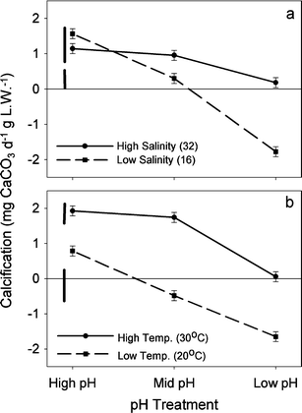comparing the effects of salinity (and TA) along pH treatments and temp treatments.
* High pH high the highest calcification (low S slightly higher and amb S), this also occurred at the highest TA
* The effect of high pH at high S is less than when coupled with decreasing S (and TA)
* *High Temp elevated calcification regardless of pH, and there was an independent decline in calcification from pH (similar to sal curve)*.
* The effect of pH at high S was minimal (black solid line)
* The effect of pH between S (and low TA) treatments were strong (dashed line)
* **We saw highest growth rates in the low salinity coupled with high alkalinity treatment, suggesting that oysters were able to optimize on their preferred condition quickly (effect was apparent by two weeks), with elevated TA becoming more important following the two week period, marginally.**
* **They didn’t see a strong effect of pH at ambient salinity; we didn’t see a strong effect of TA (and subsequently omega) at ambient salinity. The effect of diluting TA with freshwater (rain/hurricane) will also decrease the pH, and they showed it decreased calcification. We see that there is elevated growth when TA is elevated in low S, suggesting that the effect of low pH may not be as strong.**

Dickinson 2013: Hard shell clams

* Low S (and low TA) had profound effects on survival, energy metabolism and biomineralization of hard-shell clams
* Low S (and low TA) modulated clam response to high CO2
* Negative effects of low salinity (and low TA) were mostly due to the strongly elevated basal energy demand, indicating energy deficiency, that led to reduced growth, elevated mortality and impaired shell maintenance (evidenced by the extensive damage to the periostracum).
* Moderate hypercapnia (similar to 800 mu atm P-CO2) increased shell and tissue growth and reduced mortality high salinity exposures
* these effects were abolished under the low salinity (and low TA) conditions or at high P-CO2 (similar to 1500 mu atm)
* **similar: we saw trends of decreased survival in low S and low TA conditions only (but not profound effects like them). Difference: We did not see effects of low S and low TA on energy metabolism (ie gut wt). New material: we did see an elevated shell growth response to low S conditions coupled with high TA (they didn’t test). If low S doesn’t necessarily mean low TA, then estuaries may not experience the harmful consequences of high CO2. Moderate elevations in CO2 raised shell and tissue growth rates (maybe some sort of physio priming), like we see in low S and high TA?**

Gazeau 2013: Review

* in Benaish 2010 shell area was not impacted by high CO2 but shell mass lowered. This suggests that shells were thinner under high co2 conditions. As a note, their treatments spanned below omega calcite threshold of 1.
* (B) They suggest that shell area or length may not be sufficiently accurate as indicators of the effects of OA without measuring mass as well.
* **Our shell area was also not impacted by varying TA (and omega), which correlate with CO2. We did NOT see an effect of low TA on shell mass (ie shells were not thinner). Both our treatments and their span a range of omega values above and below 1. Suggest that just area or length may not be sufficient without understanding of mass.**

Hollarsmith 2019): Ostrea lurida and Crassostrea gigas

* the influence of carbonate system parameters, temperature, salinity, dissolved oxygen (DO) gradients is contingent upon the location in the estuary as well as seasonal timing (Hollarsmith 2019).
* During upwelling events (dry season), temperature, carbonate chemistry, and DO had the greatest impact on oyster performance. (Hollarsmith 2019)
* During runoff events (wet season), gradients in salinity, nutrient concentrations, and total alkalinity driven by river discharge were comparatively more important. (Hollarsmith 2019)
* the spatial importance *of carbonate chemistry and temperature* are seasonally variable and are two of several other factors that determine oyster performance. (Hollarsmith 2019)
* **Context for performance patterns overall: Performance was highest in upwelling season and declines following. We were between upwelling and river events and so there is some sort of transition in physio that is occurring such that, salinity, nutrients and TA are becoming more important. Future work should consider interval effects at different seasons, or consider outplants like these for CV in TX. Maybe because we were in a transition point, we saw depleted growth rates with time (coming down from upwelling?)**